Product Backlog



# **1. Product Backlog**

## **1.1. User Story Map**

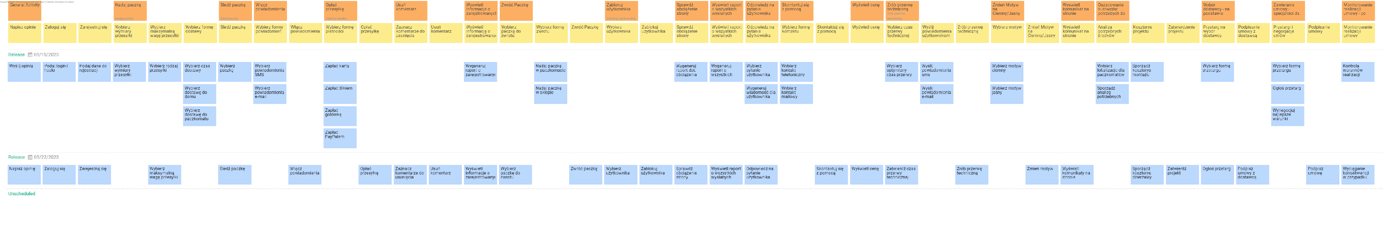

## **1.2. Prioritized User Stories**

|  |  |  |  |  |  |  |  |  |  |  |
| --- | --- | --- | --- | --- | --- | --- | --- | --- | --- | --- |
| **ID** | **Name** | **Description** | **Epic** | **Status** | **Acceptance Criteria** | **Story Points** | **Priority** | **Risk** | **Split From** | **Due Date** |